Task for today Auto scaling Group (ASG)
Q1.Create one VPC in N. Virginia region.

Step 1: Login to AWS Console
- Go to AWS Management Console
- Sign in with your account

Step 2: Select Region
- On the top right corner, select region:
👉 N. Virginia (us-east-1)

Step 3: Open VPC Dashboard
- In the search bar, type VPC
- Click on VPC Dashboard

Step 4: Create VPC
- Click "Create VPC"
- Choose:
  - VPC only (simple option)

Step 5: Configure VPC Settings
Fill the details like below:
- Name tag: MyVPC
- IPv4 CIDR block: 10.0.0.0/16
- IPv6 CIDR: No (optional)
- Tenancy: Default

Step 6: Create
- Click Create VPC
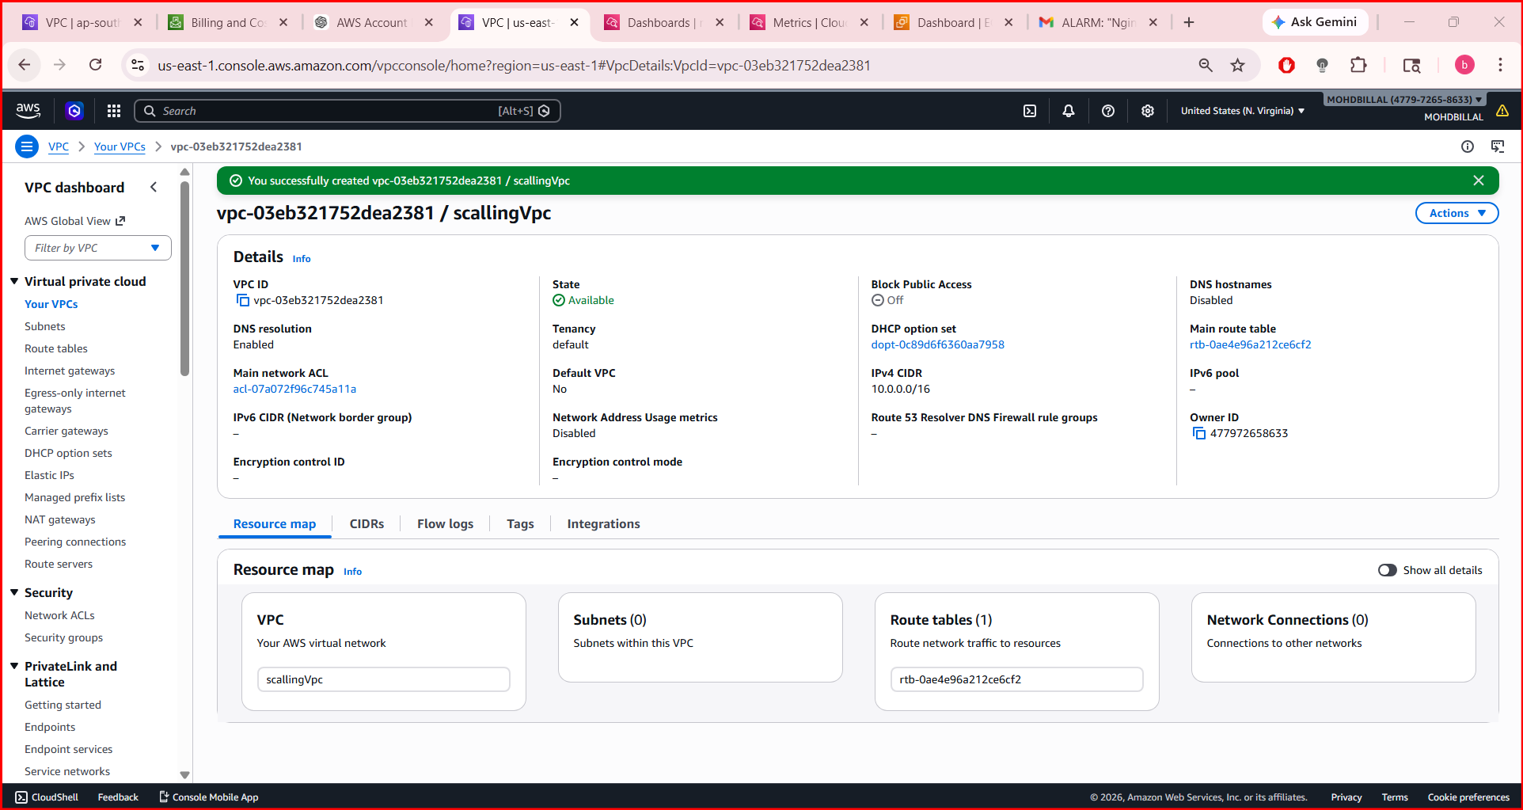
Q2. Create two subnets: one public subnet and one private subnet.

Step 1: Go to VPC Dashboard
- Open AWS Console
- Search → VPC
- Click Subnets (left side menu)

Step 2: Create Public Subnet
- Click Create subnet
- Fill details:
- VPC ID: Select your VPC (MyVPC)
- Subnet name: Public-Subnet
- Availability Zone: us-east-1a
- IPv4 CIDR block: 10.0.1.0/24
Click Create subnet
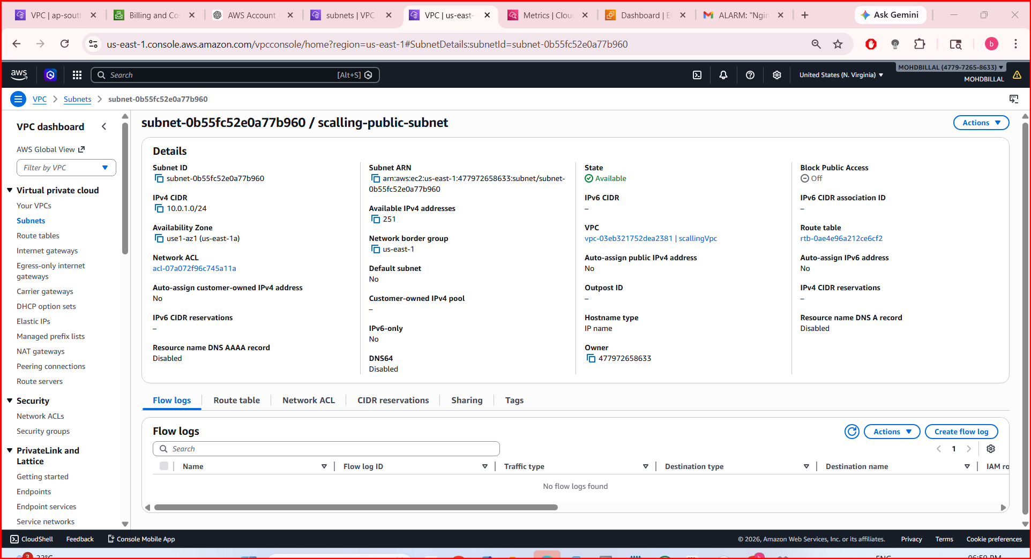

Step 3: Create Private Subnet
- Again click Create subnet
- Fill details:
- VPC ID: Same VPC (MyVPC)
- Subnet name: Private-Subnet
- Availability Zone: us-east-1b
- IPv4 CIDR block: 10.0.2.0/24
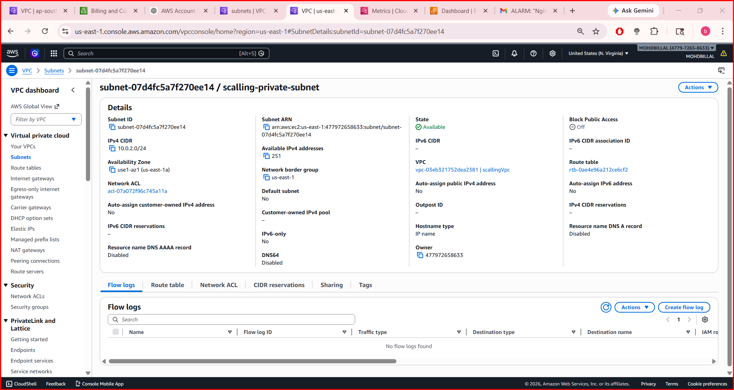
Click Create subnet
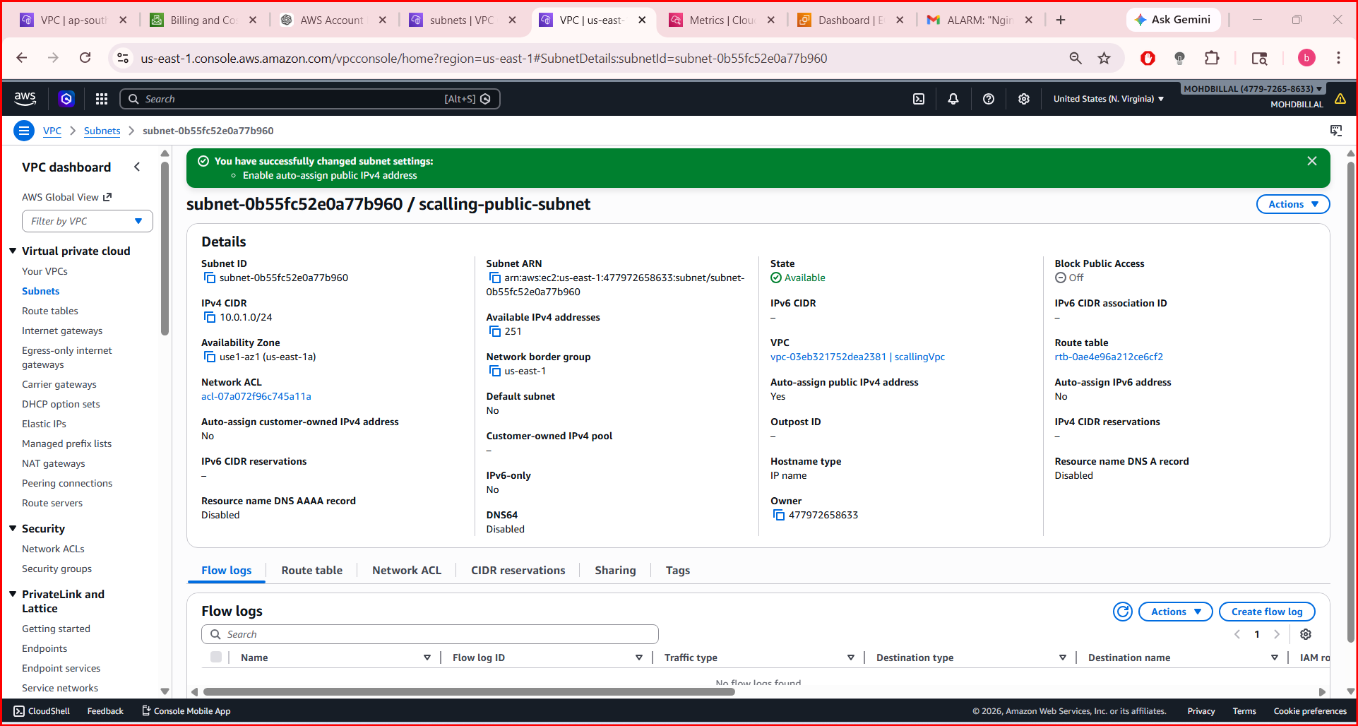
Q3. Attach an IGW to the VPC.

Step 1: Open Internet Gateways
- Go to AWS Console
- Search → VPC
- In left menu, click Internet Gateways

Step 2: Create Internet Gateway
- Click Create internet gateway
- Enter:
  - Name tag: scaling-igw
- Click Create

Step 3: Attach IGW to VPC
- Select your newly created IGW (scaling-igw)
- Click Actions → Attach to VPC
- Select your VPC:
  - scaling-vpc
- Click Attach
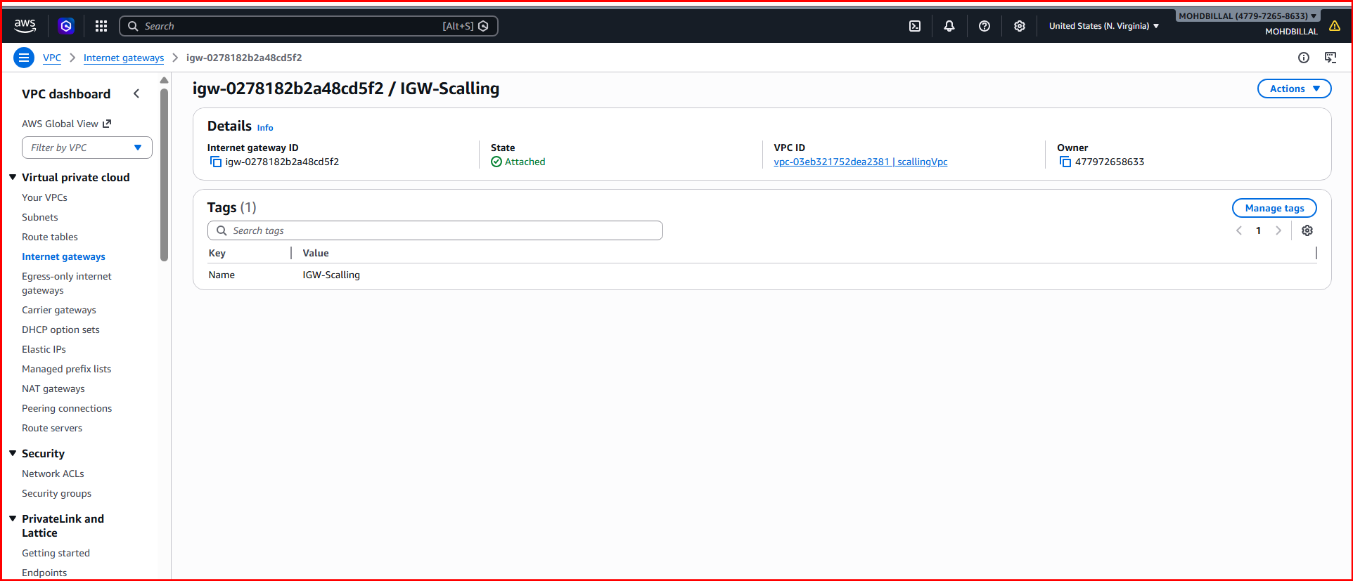
Q4. Create one public route table (RT) and one private route table.

Step 1: Go to Route Tables
- Open AWS Console
- Search → VPC
- Click Route Tables (left menu)

Step 2: Create Public Route Table
- Click Create route table
- Enter:
  - Name: public-rt
  - VPC: scaling-vpc
- Click Create

Step 3: Add Internet Route (VERY IMPORTANT)
- Select public-rt
- Go to Routes tab
- Click Edit routes → Add route
Fill:
- Destination: 0.0.0.0/0
- Target: Select your IGW (scaling-igw)
Click Save

Step 4: Associate Public Subnet
- Go to Subnet associations tab
- Click Edit subnet associations
- Select:
  - Public-Subnet
- Click Save

🌐 Public Route Table DONE ✅

Step 5: Create Private Route Table
- Click Create route table
- Enter:
  - Name: private-rt
  - VPC: scaling-vpc
- Click Create

Step 6: Associate Private Subnet
- Select private-rt
- Go to Subnet associations
- Click Edit subnet associations
- Select:
  - Private-Subnet
- Click Save
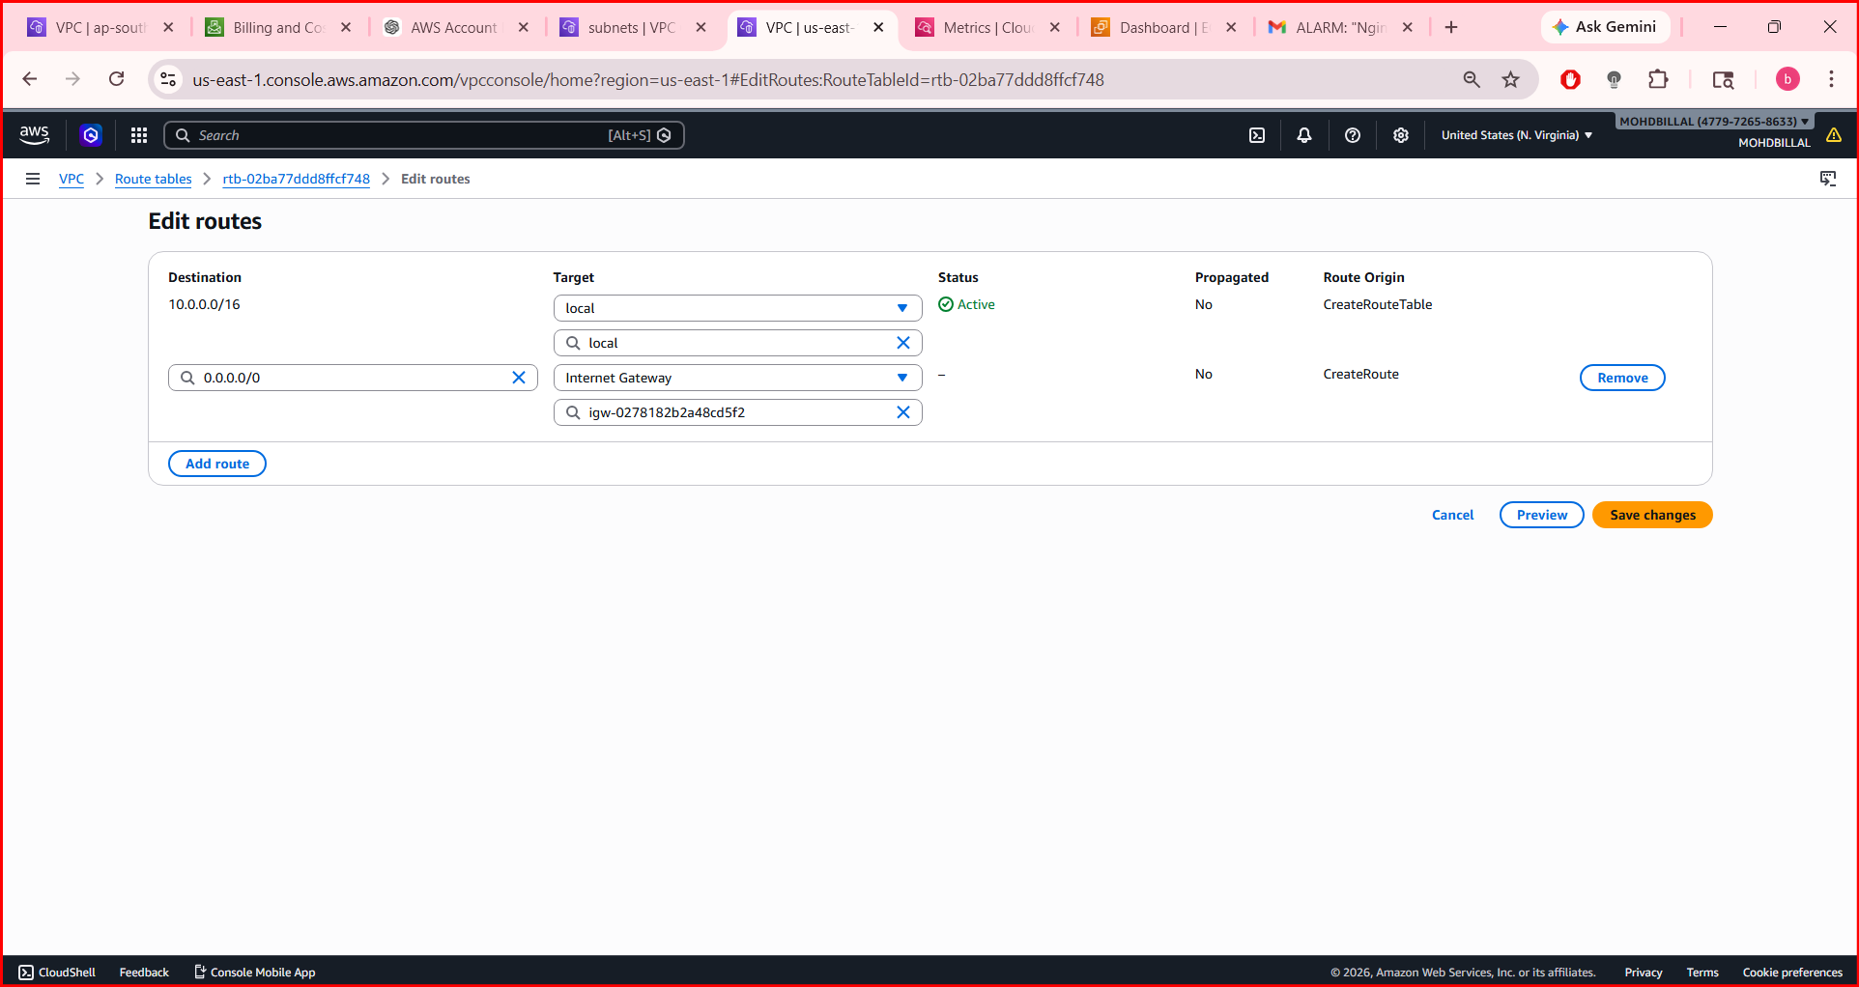
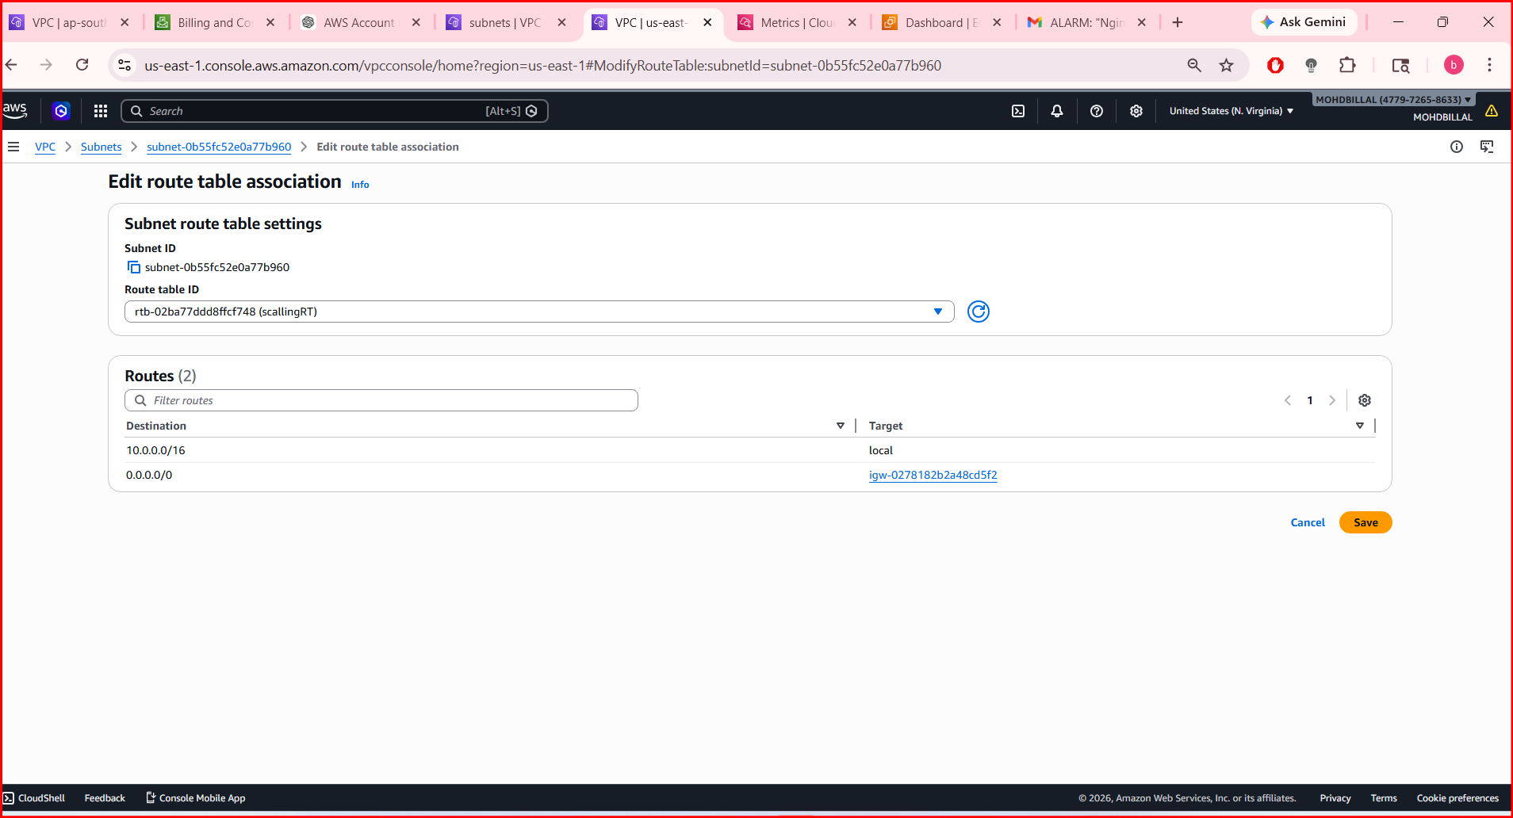
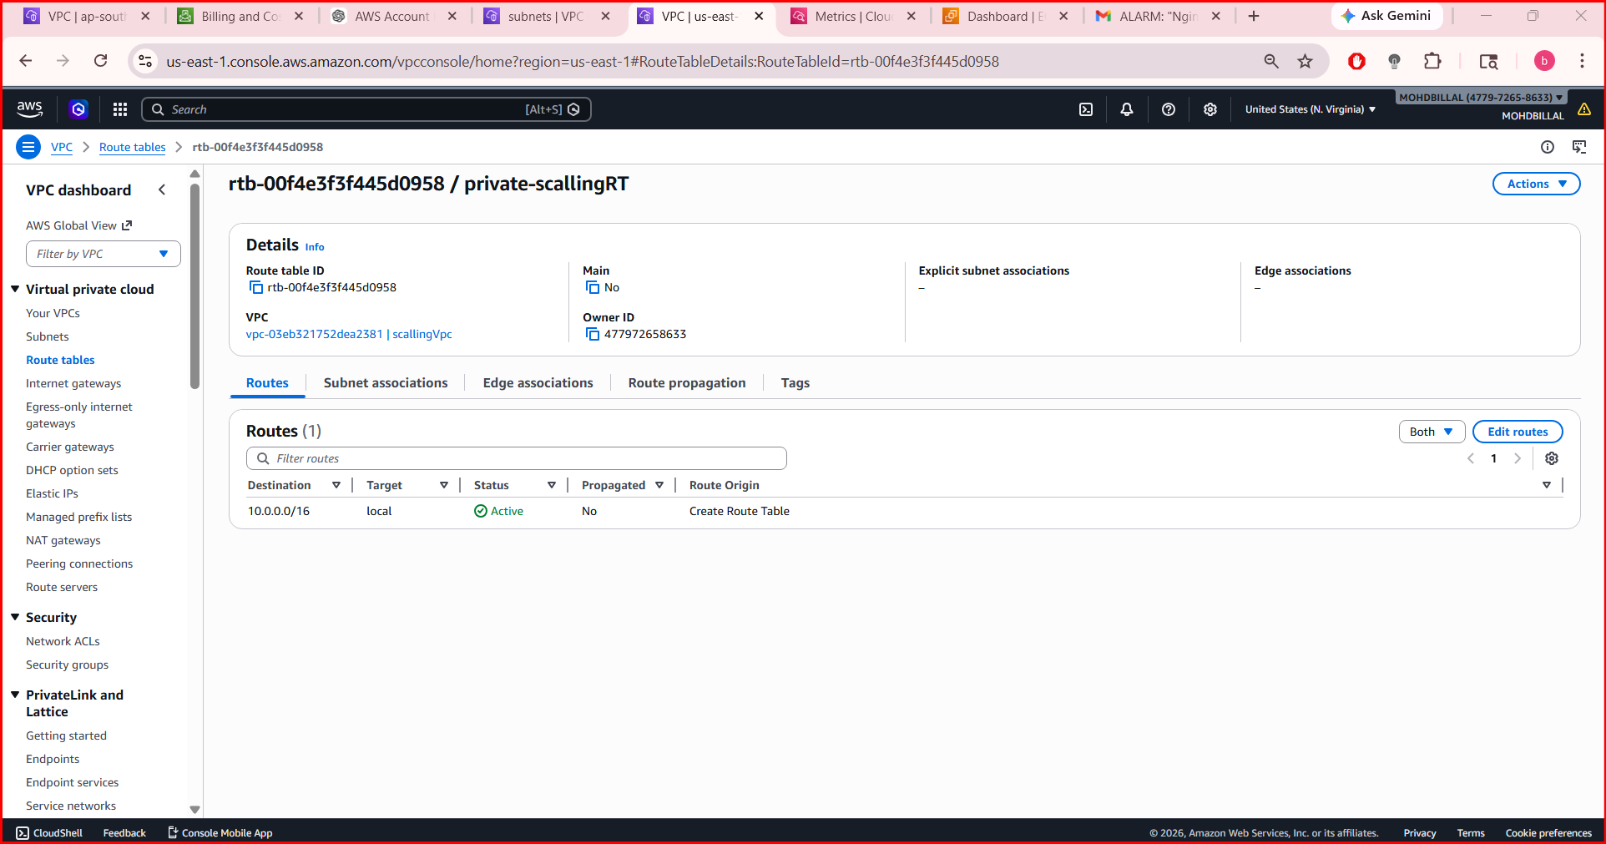
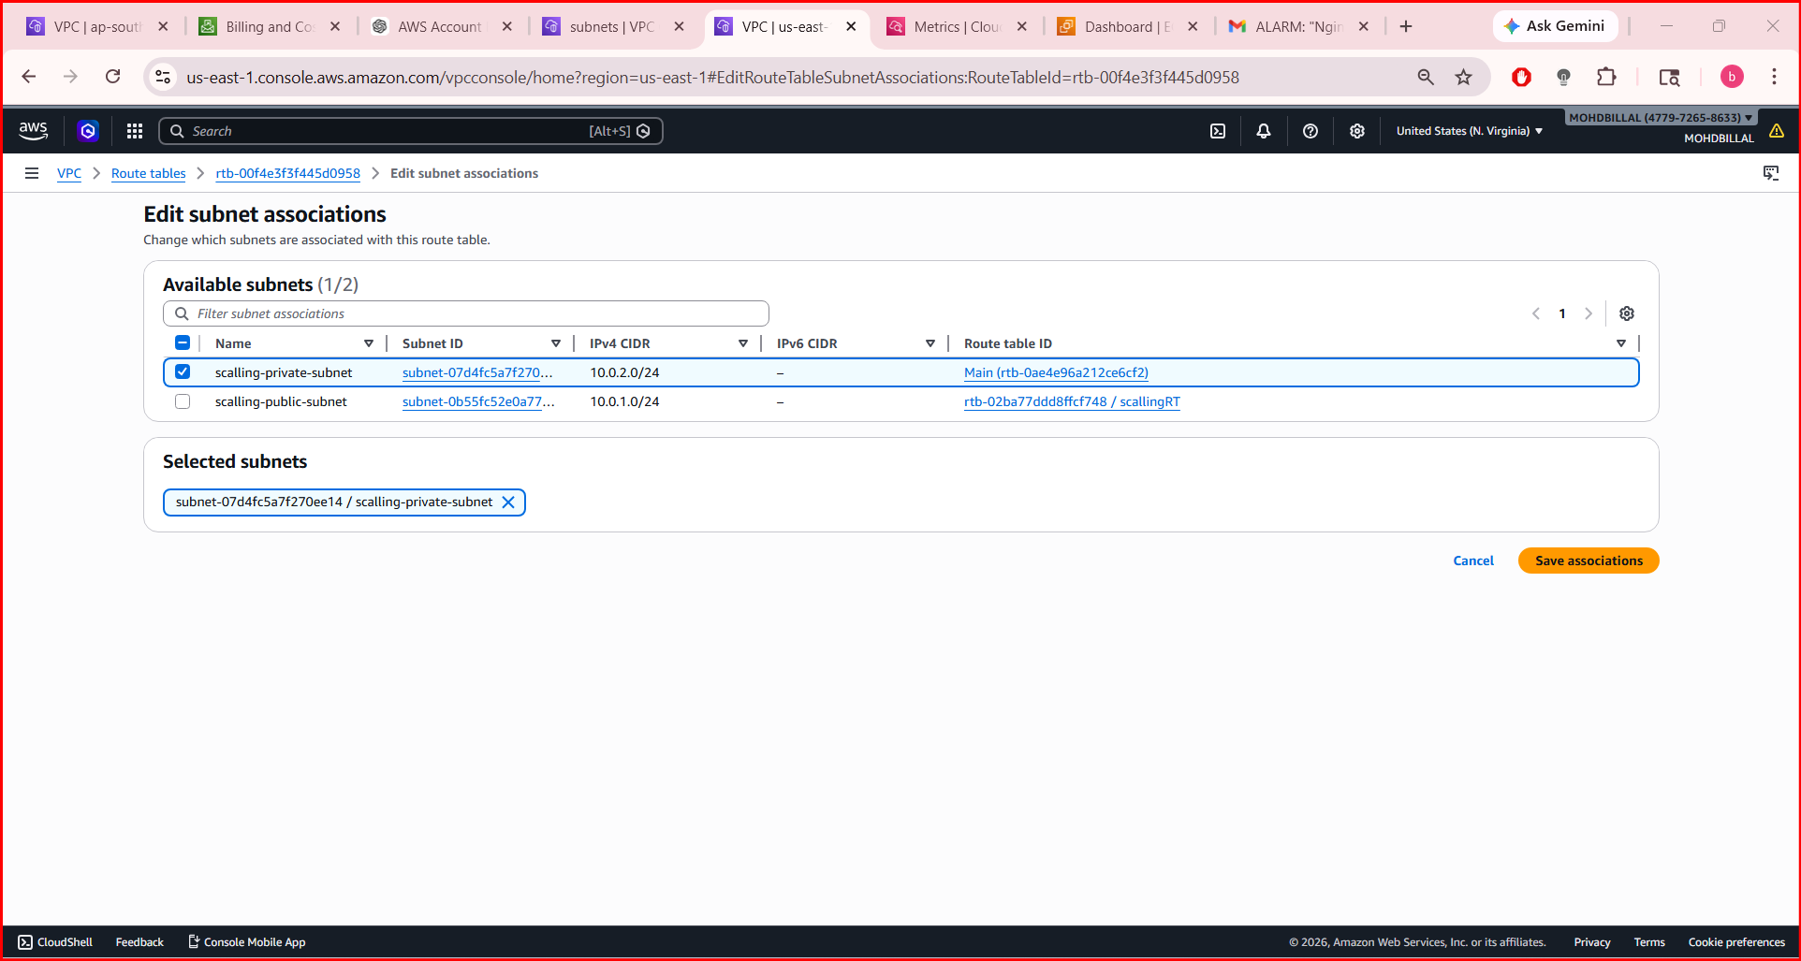

Q5. Deploy a NAT gateway in the public subnet and attach the NAT gateway to the private subnet.

PART 1: Create NAT Gateway

Step 1: Go to NAT Gateways
- Open AWS Console
- Search → VPC
- Click NAT Gateways (left menu)

Step 2: Create NAT Gateway
- Click Create NAT Gateway
Fill details:
- Name: scaling-nat
- Subnet: Select your Public-Subnet ✅ (VERY IMPORTANT)
- Connectivity type: Public
- Elastic IP: Click Allocate Elastic IP
Click Create NAT Gateway

Wait
- Status will show Pending → Available
- Wait until it becomes Available

🔒 PART 2: Attach NAT to Private Subnet (via Route Table)

Step 3: Go to Route Tables
- Click Route Tables

Step 4: Select Private Route Table
- Choose private-rt

Step 5: Edit Routes
- Go to Routes tab
- Click Edit routes
- Click Add route
Fill:
- Destination: 0.0.0.0/0
- Target: Select NAT Gateway (scaling-nat)
Click Save changes
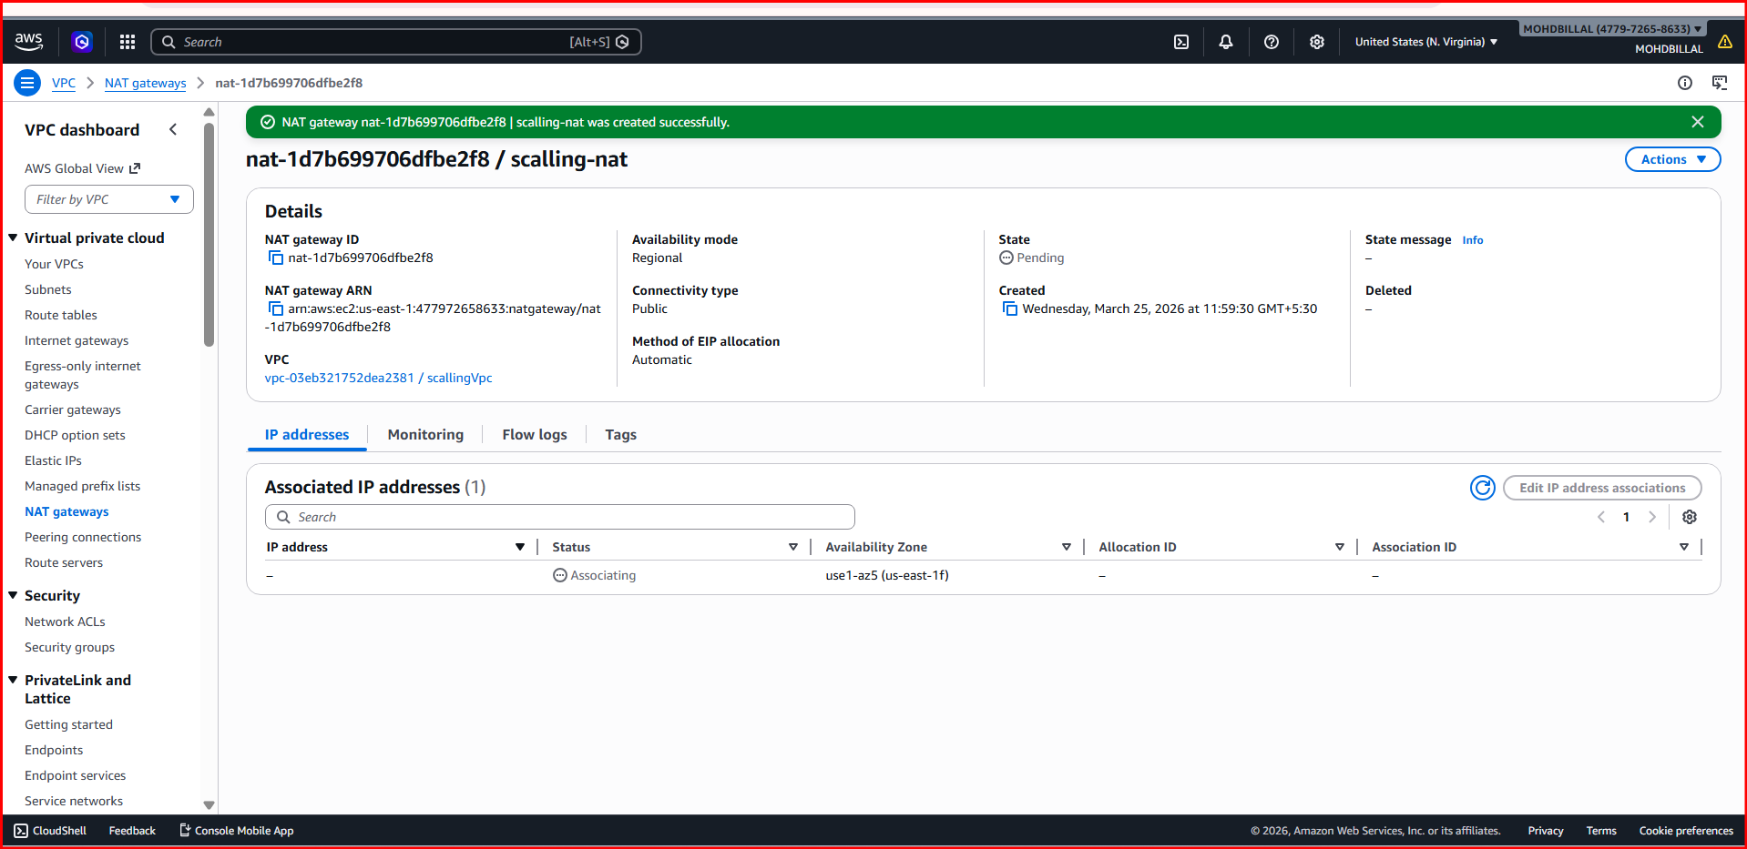
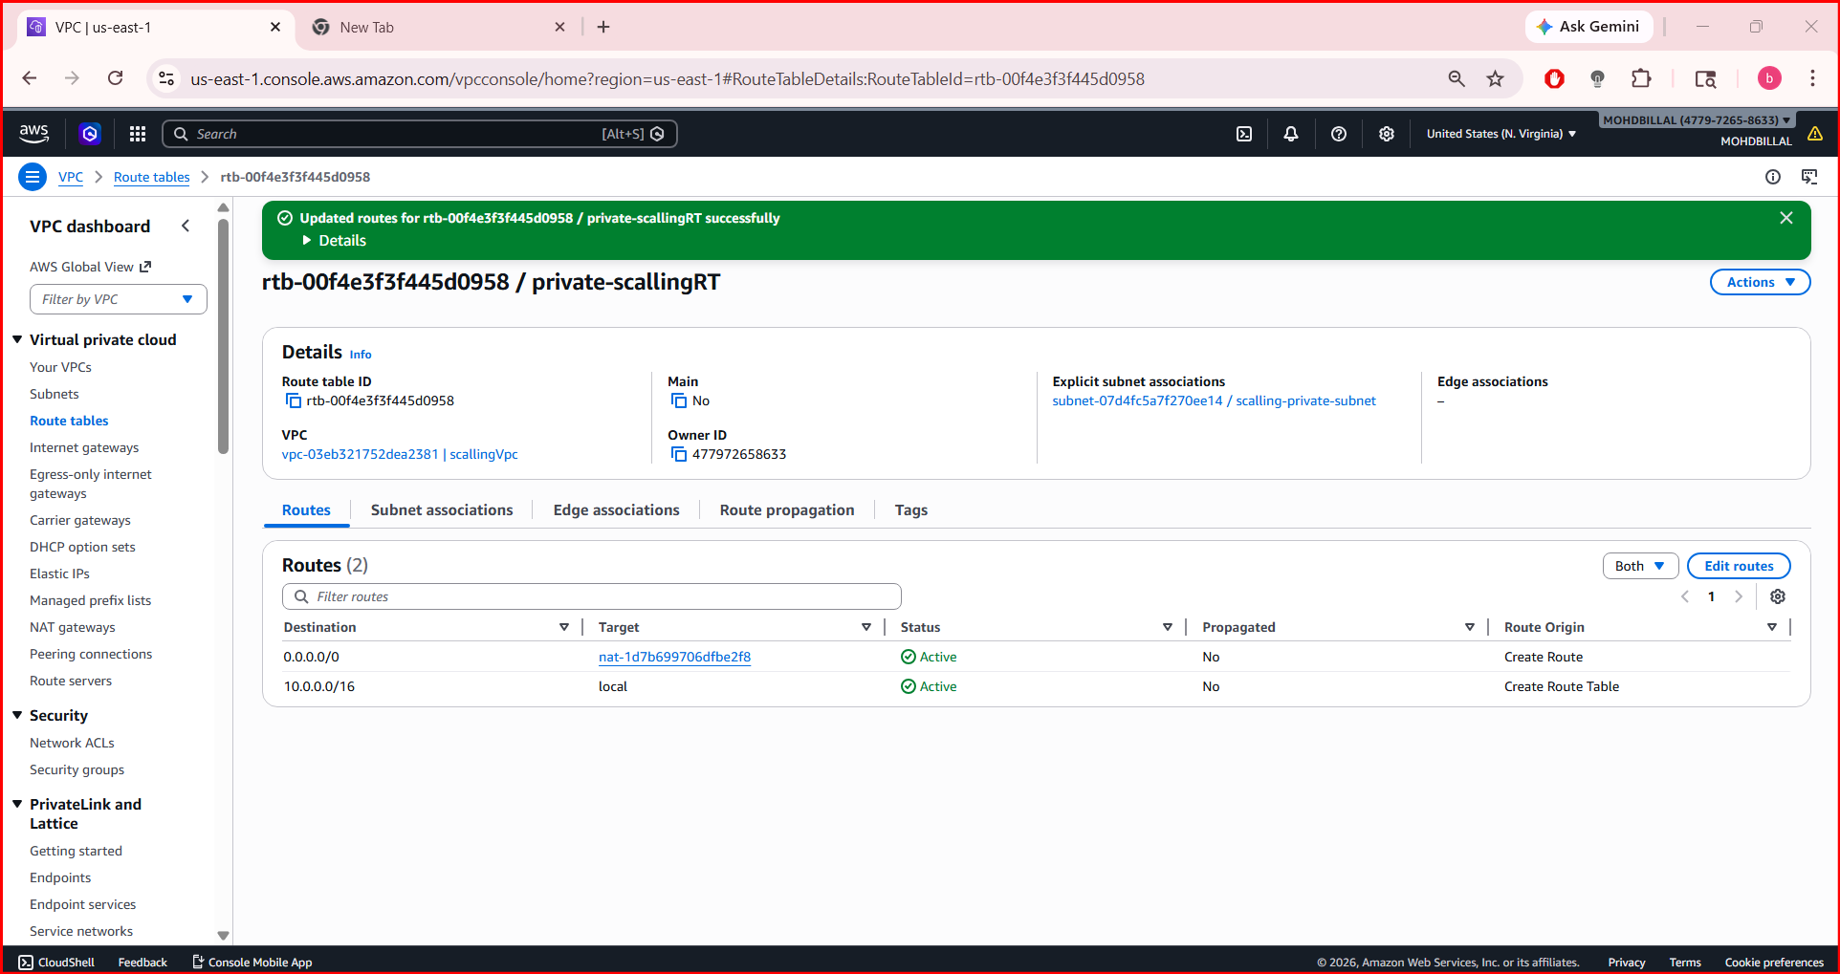
Q6. Create two instances, one in the public subnet and one in the private subnet.

PART 1: Launch EC2 in Public Subnet (Bastion Host)

Step 1: Go to EC2
- Open AWS Console
- Search → EC2
- Click Launch Instance

Step 2: Configure Instance
Fill details:
- Name: public-ec2
- AMI: Amazon Linux 2
- Instance type: t2.micro (free tier)

Step 3: Key Pair
- Select existing key OR
- Click Create new key pair (download .pem file)

Step 4: Network Settings
Click Edit:
- VPC: scaling-vpc
- Subnet: Public-Subnet
- Auto-assign Public IP: ✅ Enable

Step 5: Security Group
Create new:
- Name: public-sg
- Add inbound rules:
  - SSH → Port 22 → Source: My IP
  - (Optional) HTTP → Port 80 → Anywhere

Step 6: Launch
👉 Click Launch Instance

🌐 PART 2: Launch EC2 in Private Subnet

Step 1: Launch Another Instance
- Click Launch Instance

Step 2: Configure
- Name: private-ec2
- AMI: Amazon Linux 2
- Instance type: t2.micro

Step 3: Key Pair
- Use same key pair as above

Step 4: Network Settings
Click Edit:
- VPC: scaling-vpc
- Subnet: Private-Subnet
- Auto-assign Public IP: ❌ Disable

Step 5: Security Group
Create new:
- Name: private-sg
- Add inbound rule:
  - SSH → Port 22 → Source: public-ec2 private IP OR public-sg
👉 Best practice:
- Source = public-sg (secure)

Step 6: Launch
👉 Click Launch Instance

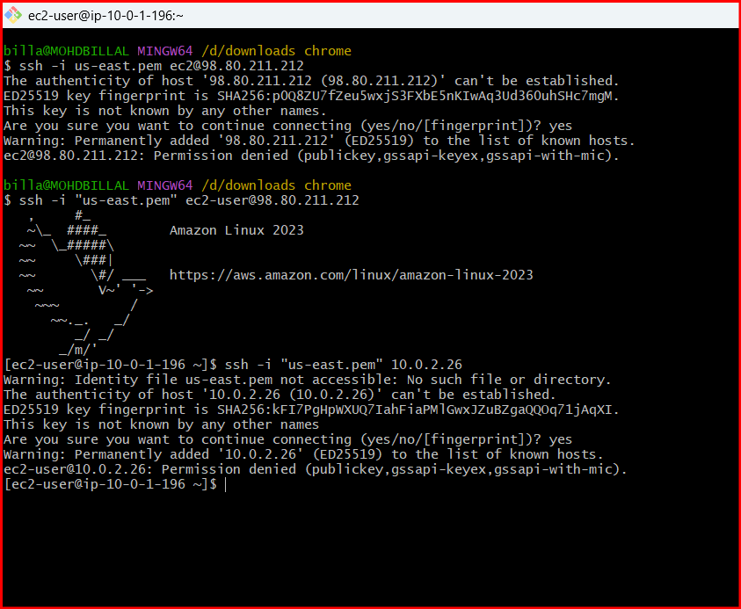
Q7. Deploy Apache server on both EC2 instances with a sample index.html file.

PART 1: Setup Apache on Public EC2

Step 1: Connect to Public EC2
ssh -i key.pem ec2-user@<public-ip>

Step 2: Install Apache
sudo yum update -y
sudo yum install httpd -y

Step 3: Start & Enable Apache
sudo systemctl start httpd
sudo systemctl enable httpd

Step 4: Create Sample index.html
sudo vi /var/www/html/index.html
Paste:
<h1>Public EC2 - Apache Server</h1>
<p>This is running on Public Subnet</p>
Save (ESC + :wq)

Step 5: Allow HTTP in Security Group
- Go to EC2 → Security Groups
- Edit public-sg
- Add:
  - HTTP → Port 80 → Anywhere (0.0.0.0/0)

Step 6: Test in Browser 🌐
Open:
http://<public-ip>
👉 You should see your webpage ✅

🔒 PART 2: Setup Apache on Private EC2

Step 1: Connect to Public EC2 (Bastion)
ssh -i key.pem ec2-user@<public-ip>

Step 2: Connect to Private EC2
ssh -i key.pem ec2-user@<private-ip>

Step 3: Install Apache
sudo yum update -y
sudo yum install httpd -y

Step 4: Start & Enable
sudo systemctl start httpd
sudo systemctl enable httpd

Step 5: Create index.html
sudo vi /var/www/html/index.html
Paste:
<h1>Private EC2 - Apache Server</h1>
<p>This is running on Private Subnet</p>
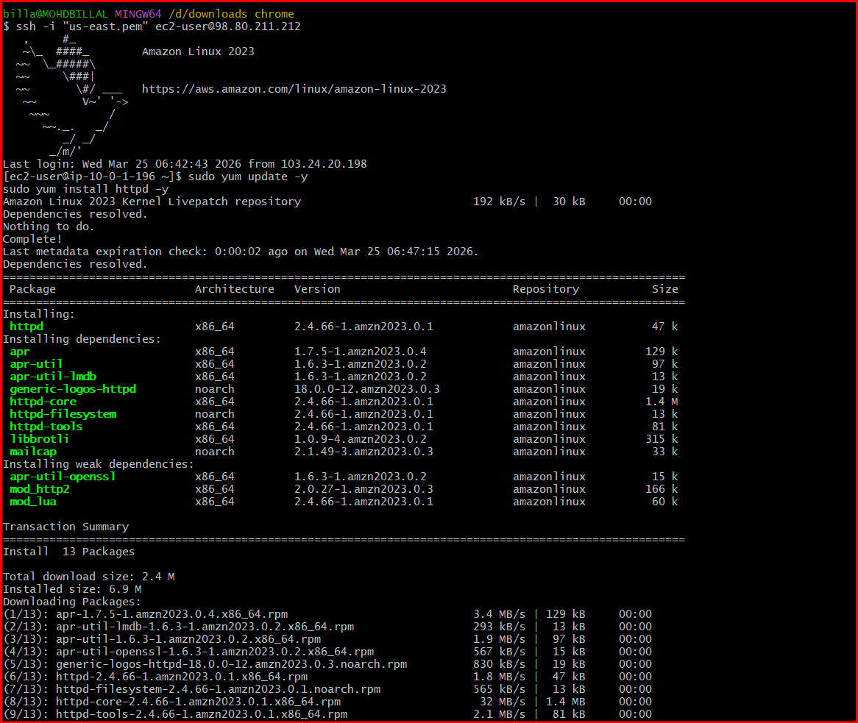
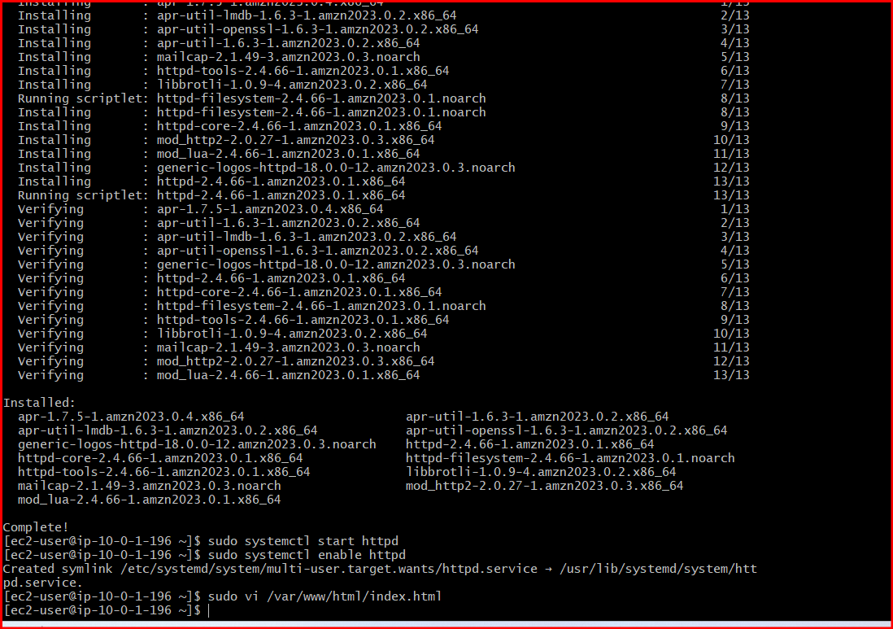
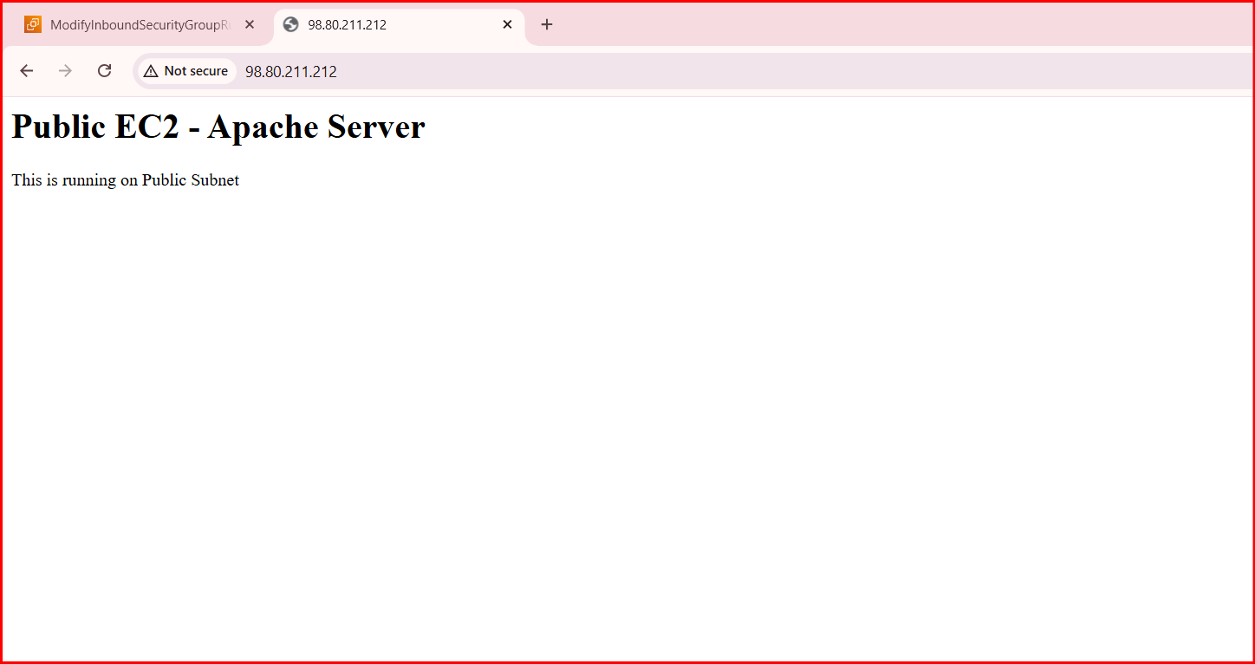
Q8. Create one application load balancer and attach it to both EC2 instances.

Step 1: Go to Load Balancer
- Open AWS Console
- Search → EC2
- In left menu → Click Load Balancers
- Click Create Load Balancer

Step 2: Choose Type
- Select Application Load Balancer
- Click Create

Step 3: Basic Configuration
Fill details:
- Name: scaling-alb
- Scheme: Internet-facing ✅
- IP type: IPv4

Step 4: Network Mapping
- VPC: scaling-vpc
- Mappings (VERY IMPORTANT):
  - Select at least 2 Availability Zones
  - Example:
    - us-east-1a → Public-Subnet
    - us-east-1b → Public-Subnet (or another public subnet if exists)
👉 ALB must be in public subnets only

Step 5: Security Group
Create or select:
- Name: alb-sg
- Inbound rules:
  - HTTP → Port 80 → 0.0.0.0/0

Step 6: Configure Target Group
Click Create target group

Fill:
- Target type: Instances
- Name: tg-scaling
- Protocol: HTTP
- Port: 80
- VPC: scaling-vpc
👉 Click Next

Step 7: Register Targets (Attach EC2)
- Select:
  - public-ec2
  - private-ec2
👉 Click Include as pending below
👉 Click Create target group

Step 8: Attach Target Group to ALB
- Go back to ALB creation
- Select:
  - Listener: HTTP : 80
  - Forward to → tg-scaling
👉 Click Create Load Balancer

⏳ Wait
- Status → Provisioning → Active

Step 9: Test ALB
- Copy DNS name of ALB
- Open in browser:
http://<alb-dns-name>

- You will see:
  - Public EC2 page OR
  - Private EC2 page
👉 It will switch between both (load balancing)

👉 Update Private Security Group
- Go to private-sg
- Add inbound rule:
  - HTTP (80)
  - Source → alb-sg
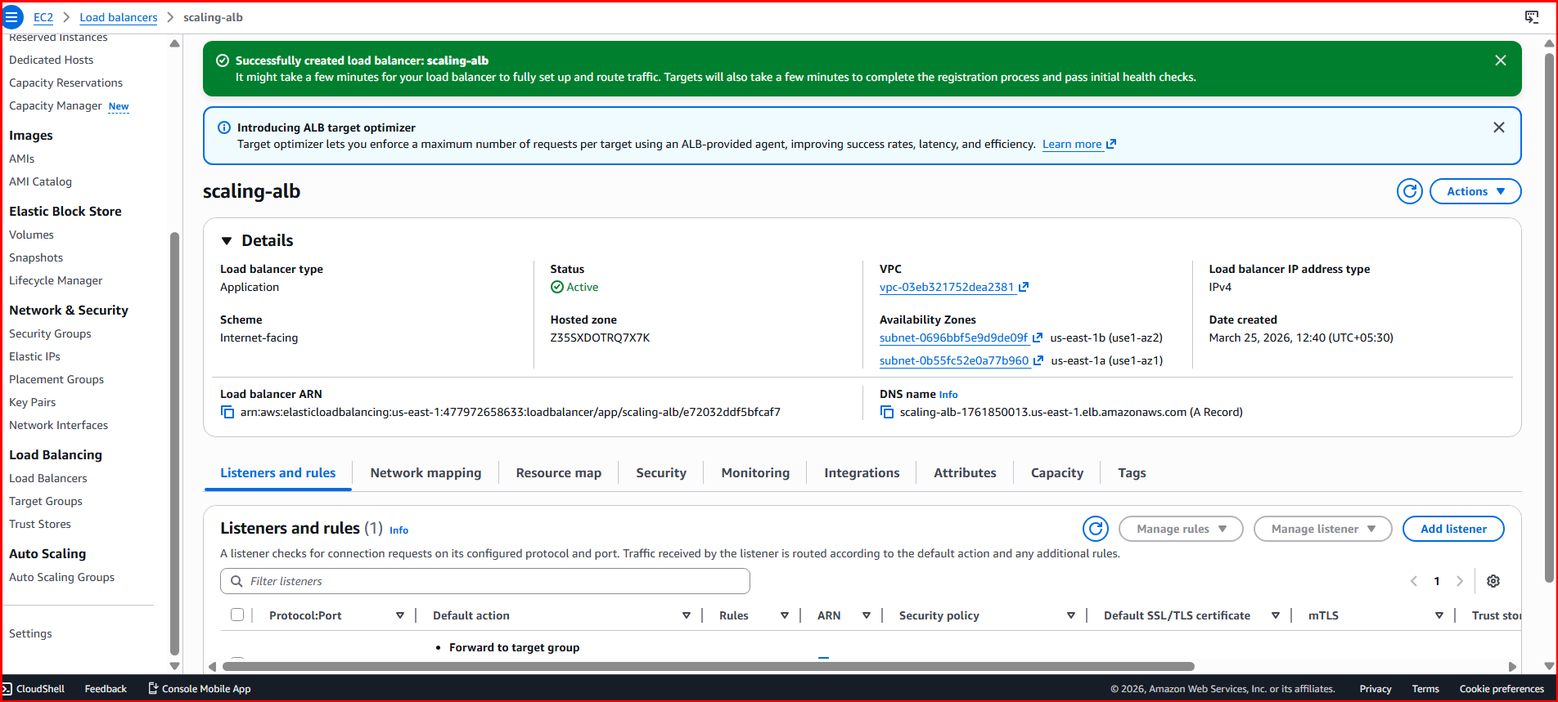
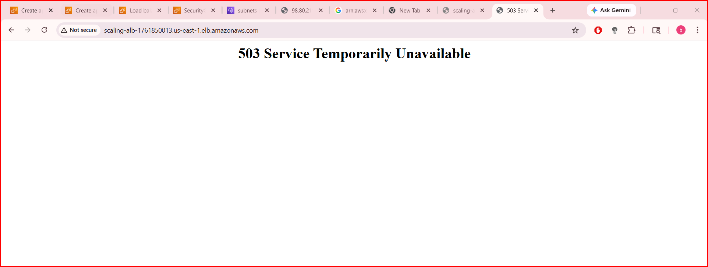
Q9. Store application load balancer logs in S3.

Step-by-Step: Store ALB Logs in S3
We’ll do 3 main things:
- Create S3 bucket
- Add bucket policy (VERY IMPORTANT)
- Enable ALB logging

Step 1: Create S3 Bucket
- Go to AWS Console
- Search → S3
- Click Create bucket
Fill:
- Bucket name: scaling-alb-logs-<unique-name>
(must be globally unique)
- Region: same as ALB → N. Virginia
- Keep all default settings
👉 Click Create bucket

Step 2: Add Bucket Policy (CRITICAL)
- Open your bucket
- Go to Permissions tab
- Scroll → Bucket policy → Edit
👉 Paste this (replace YOUR-BUCKET-NAME):
{
"Version": "2012-10-17",
"Statement": [
{
"Sid": "AWSALBLogs",
"Effect": "Allow",
"Principal": {
"Service": "logdelivery.elasticloadbalancing.amazonaws.com"
},
"Action": "s3:PutObject",
"Resource": "arn:aws:s3:::YOUR-BUCKET-NAME/AWSLogs/477972658633/*"
}
]
}
👉 Click Save changes

Step 3: Enable ALB Access Logs
- Go to EC2 → Load Balancers
- Select your ALB → scaling-alb
- Go to Attributes tab
- Click Edit

Enable Logging
- Turn ON Access logs
- S3 bucket: select your bucket
- Prefix (optional): alb-logs
👉 Click Save

Step 4: Wait & Verify
- Wait 5–10 minutes
- Go to S3 bucket
- Navigate:
AWSLogs/
477972658633/
elasticloadbalancing/
👉 You will see log files 🎉

What Logs Contain
Each log file includes:
- Client IP
- Request path
- Response code (200, 503, etc.)
- Target instance
- Latency
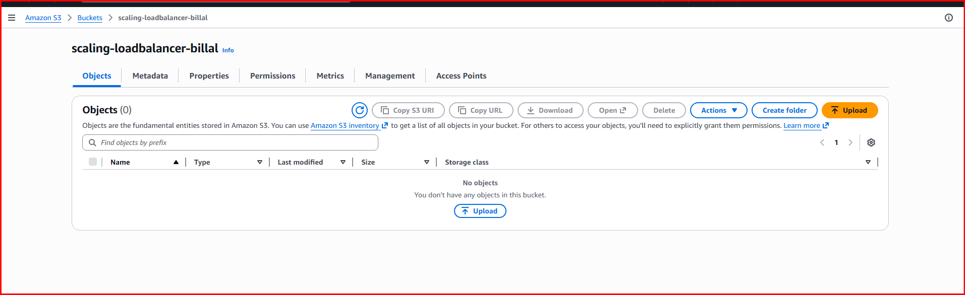
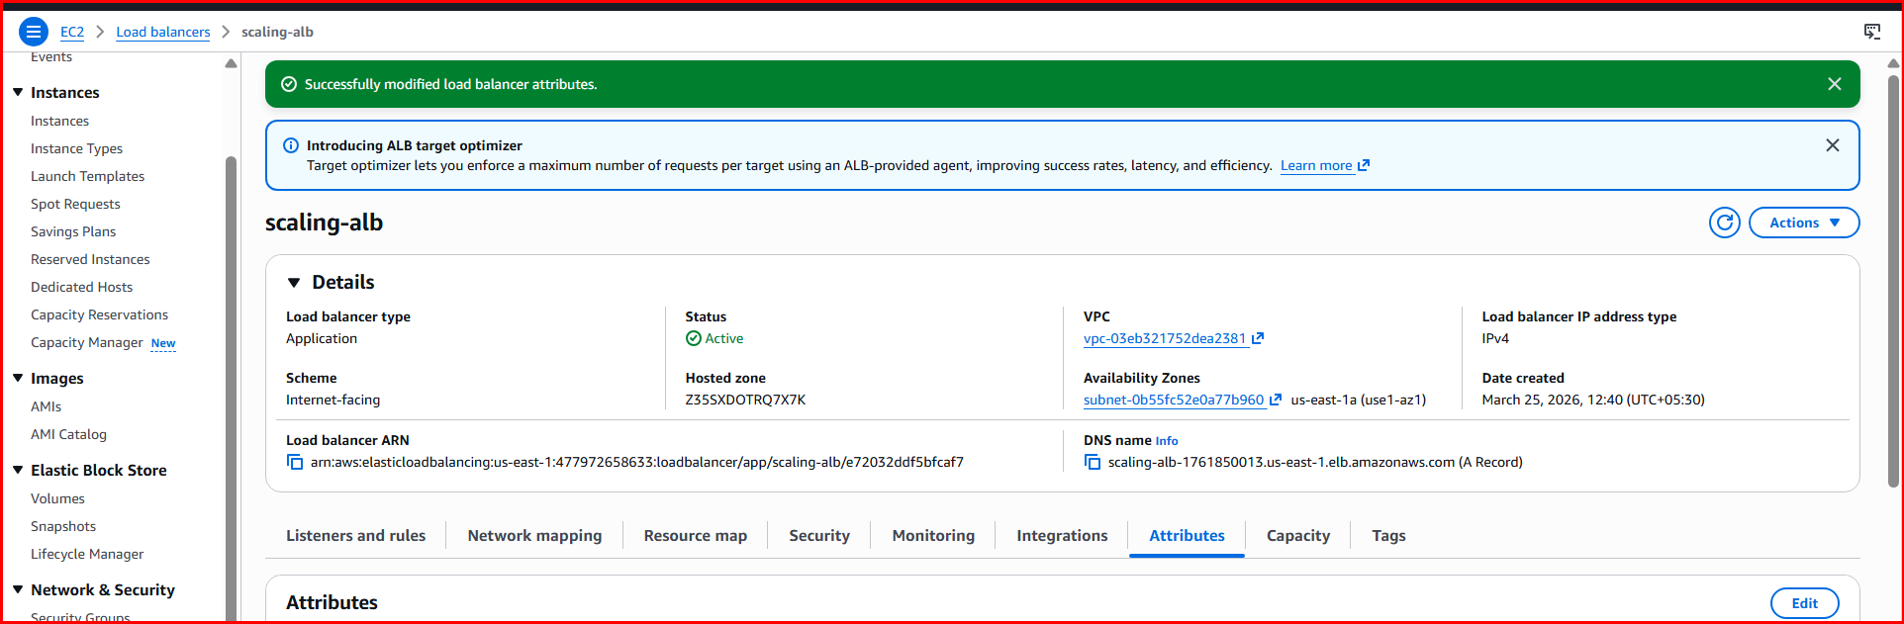
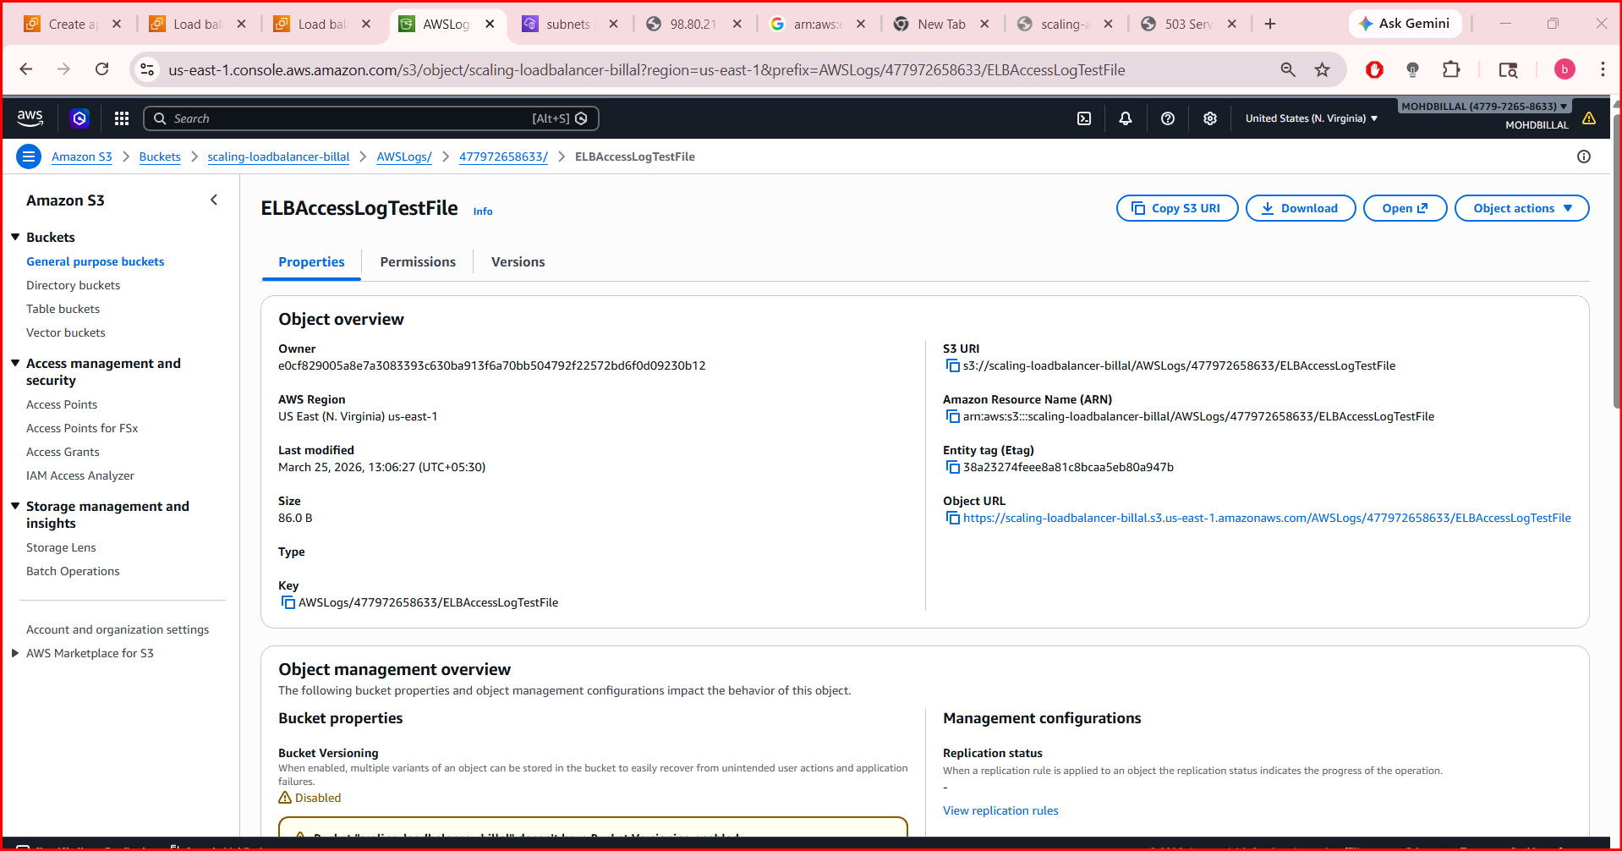

Q10. Store the VPC flow logs in a CloudWatch log group.

Step-by-Step: Store VPC Flow Logs in CloudWatch
We’ll do:
- Create CloudWatch Log Group
- Create IAM Role
- Enable VPC Flow Logs

Step 1: Create CloudWatch Log Group
- Go to AWS Console
- Search → CloudWatch
- Click Log groups
- Click Create log group
Fill:
- Name: vpc-flow-logs-group
👉 Click Create

Step 2: Create IAM Role for Flow Logs
- Go to IAM
- Click Roles → Create role

Select Trusted Entity
- Choose AWS service
- Use case:
  - Select VPC
👉 Click Next

Attach Policy
- Attach:
  - CloudWatchLogsFullAccess (for practice)
👉 Click Next

Role Name
- Name: vpc-flow-logs-role
👉 Click Create role

Step 3: Verify Trust Relationship (IMPORTANT)
Go to role → Trust relationships → Edit
Ensure it looks like this:
{
"Version": "2012-10-17",
"Statement": [
{
"Sid": "",
"Effect": "Allow",
"Principal": {
"Service": "vpc-flow-logs.amazonaws.com"
},
"Action": "sts:AssumeRole"
}
]
}
👉 Save

Step 4: Enable VPC Flow Logs
- Go to VPC Dashboard
- Click Your VPCs
- Select your VPC:
  - scaling-vpc

Create Flow Log
- Click Actions → Create flow log
Fill:
- Filter: All
- Destination: Send to CloudWatch Logs
- Log group: vpc-flow-logs-group
- IAM role: vpc-flow-logs-role
👉 Click Create flow log

Step 5: Verify Logs
- Go to CloudWatch → Log groups
- Open:
  - vpc-flow-logs-group
👉 You will see log streams after some traffic
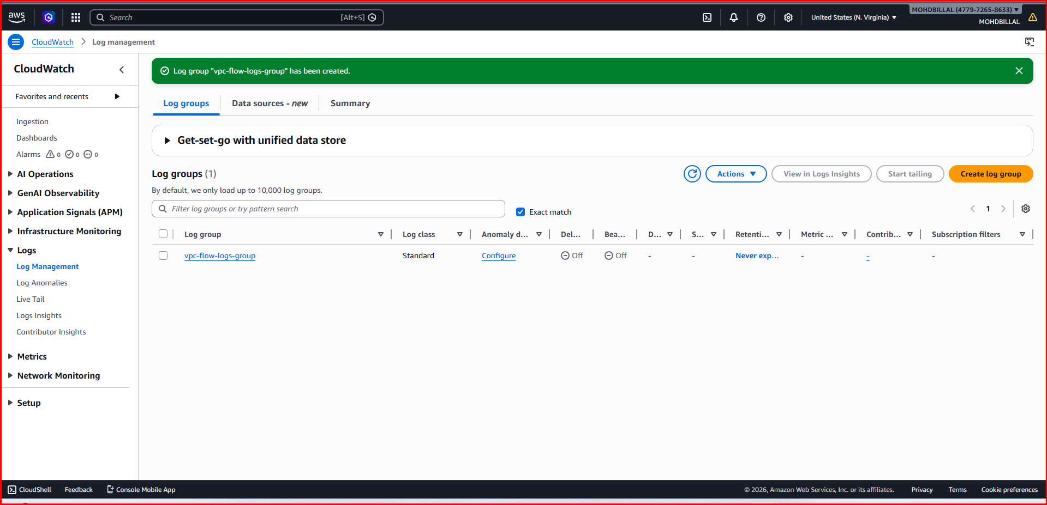
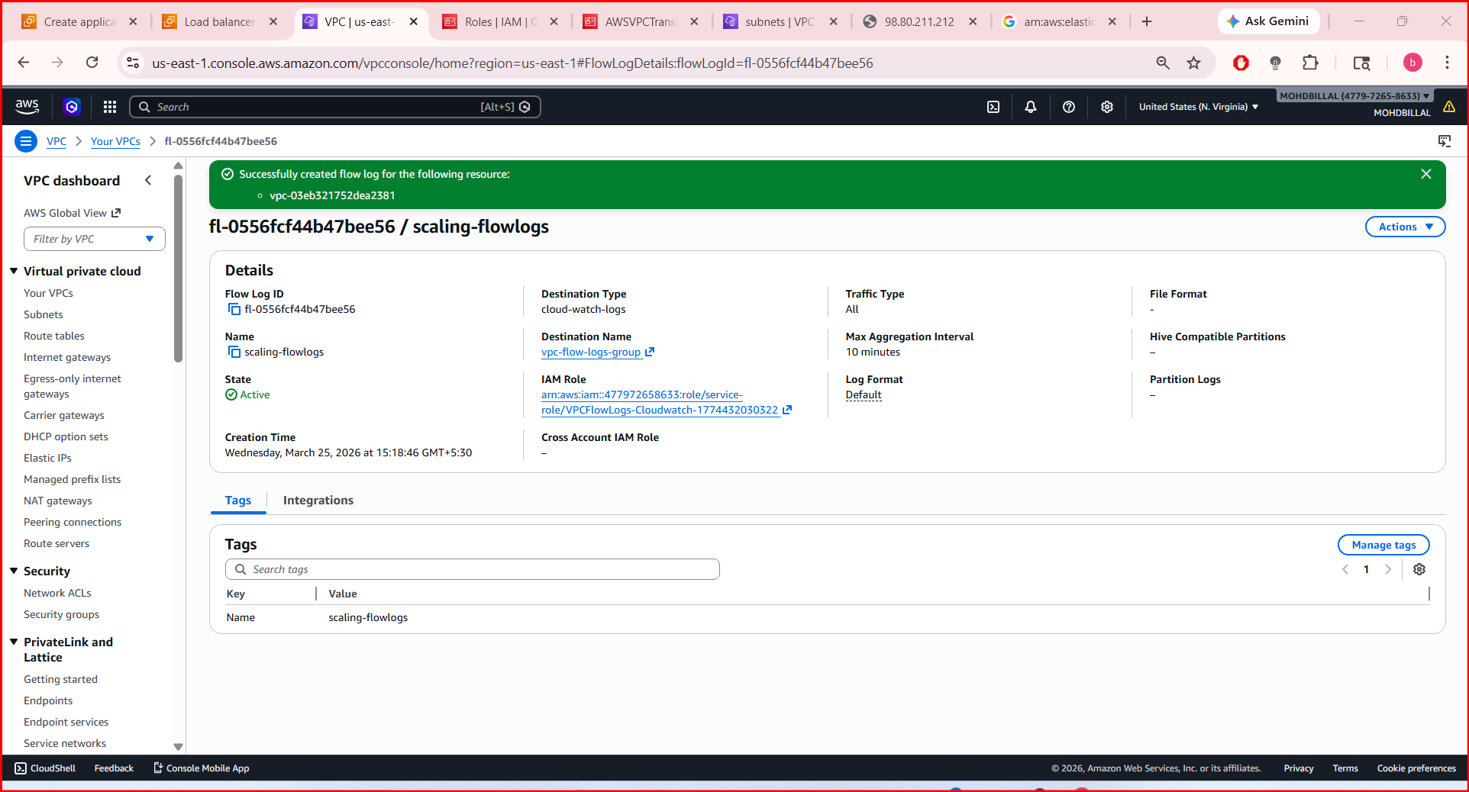
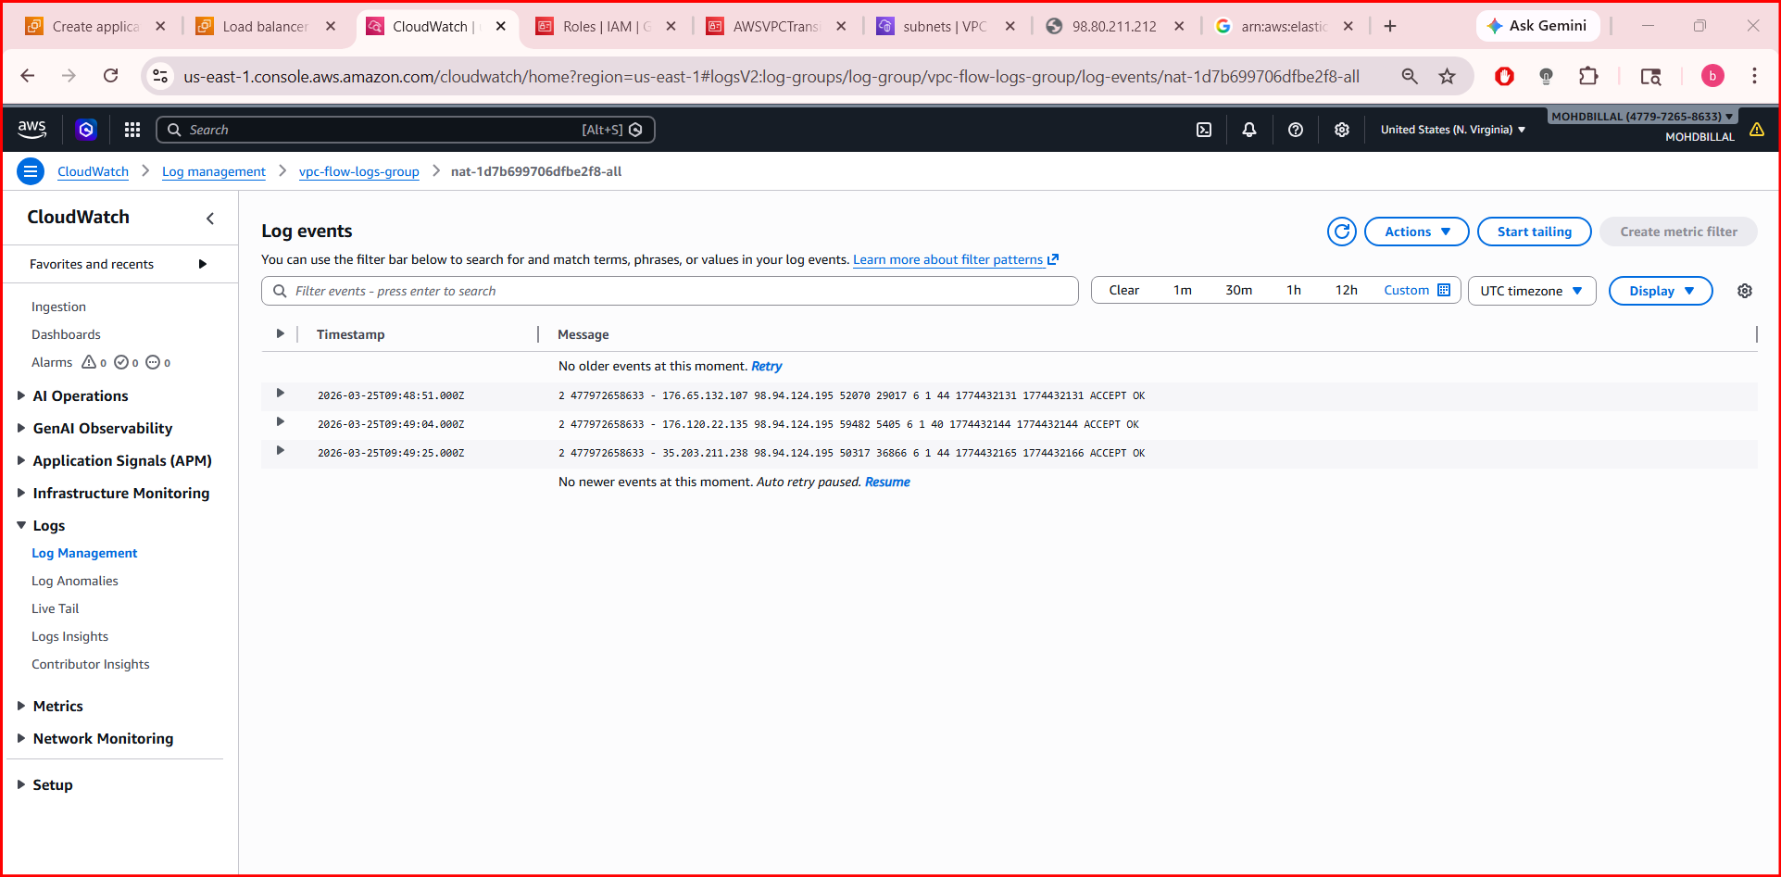
Q11. Create monitoring dashboards to monitor CPU utilization and to monitor the Apache service.

PART 1: Create CloudWatch Dashboard

Step 1: Open Dashboard
- Go to AWS Console
- Search → CloudWatch
- Click Dashboards
- Click Create dashboard

Step 2: Name Dashboard
- Name: scaling-dashboard
👉 Click Create

PART 2: Add CPU Utilization Widget

Step 3: Add Widget
- Click Add widget
- Select Line graph
- Click Next

Step 4: Select Metric
- Choose:
  - EC2 → Per-Instance Metrics
- Select:
  - CPUUtilization
- Tick both instances:
  - public-ec2
  - private-ec2
👉 Click Create widget

Step 5: Customize
- Title: EC2 CPU Utilization
- Period: 5 minutes
👉 Save

PART 3: Monitor Apache (httpd) Service
important: CloudWatch cannot directly monitor services We must use CloudWatch Agent

Step 6: Install CloudWatch Agent (on BOTH EC2)
SSH into each instance and run:
sudo yum install amazon-cloudwatch-agent -y

Step 7: Create Agent Config
Run:
sudo /opt/aws/amazon-cloudwatch-agent/bin/amazon-cloudwatch-agent-config-wizard
👉 Answer:
- Collect metrics → yes
- Collect logs → yes
- Monitor:
  - CPU, memory, disk
- Add logs:
  - /var/log/messages
  - /var/log/httpd/access_log
  - /var/log/httpd/error_log

Step 8: Start Agent
sudo systemctl start amazon-cloudwatch-agent
sudo systemctl enable amazon-cloudwatch-agent

PART 4: Add Apache Monitoring Widget

Option 1 (Simple): Logs Monitoring
- Go to CloudWatch → Log groups
- Select:
  - /var/log/httpd/error_log
Add to dashboard

Option 2 (Better): Create Custom Metric
Run on EC2:
systemctl is-active httpd
👉 If active → returns active

Create Script:
#!/bin/bash
STATUS=$(systemctl is-active httpd)
if [ "$STATUS" = "active" ]; then
VALUE=1
else
VALUE=0
fi
aws cloudwatch put-metric-data \
--metric-name ApacheStatus \
--namespace CustomMetrics \
--value $VALUE
👉 Run this via cron every 1 min

Step 9: Add Apache Widget
- Dashboard → Add widget
- Select:
  - Custom namespace → CustomMetrics
- Choose:
  - ApacheStatus
👉 Create widget
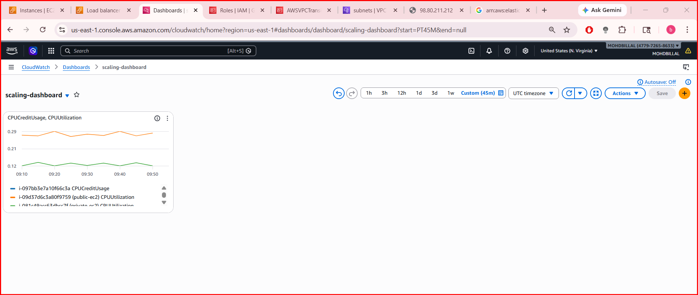

Q12. If CPU utilization is more than 70%, then it should trigger auto scaling and launch new instance.

PART 1: Create Launch Template

Step 1: Go to Launch Templates
- Open EC2 Console
- Click Launch Templates
- Click Create launch template

Step 2: Configure Template
- Name: scaling-template
- AMI: Amazon Linux 2
- Instance type: t2.micro
- Key pair: Select your key
Step 3: Network Settings
- Security group: select your existing (private-sg or web SG)

Step 4: Add User Data (VERY IMPORTANT)
This installs Apache automatically:
#!/bin/bash
yum update -y
yum install httpd -y
systemctl start httpd
systemctl enable httpd
echo "<h1>Auto Scaled Instance</h1>" > /var/www/html/index.html

👉Click Create launch template

PART 2: Create Auto Scaling Group

Step 5: Go to Auto Scaling Groups
- Click Create Auto Scaling group

Step 6: Select Template
- Choose:
  - scaling-template

Step 7: Network
- VPC: scaling-vpc
- Subnets: select:
  - Public-Subnet
  - Private-Subnet (optional but better)

Step 8: Attach Load Balancer
- Select:
  - Attach to existing load balancer
- Choose:
  - scaling-alb
- Select target group:
  - tg-scaling

Step 9: Set Capacity
- Desired capacity: 2
- Min: 1
- Max: 4

PART 3: Create Scaling Policy Step 10: Scaling Policy
Choose:
- Target tracking scaling policy

Configure:
- Metric type: Average CPU utilization
- Target value: 70%
👉 This means:
- CPU > 70% → scale OUT (add instance)
- CPU < 70% → scale IN

👉 Click Next → Create ASG

🎉 DONE!

🧪 PART 4: Test Auto Scaling

Step 11: Increase CPU Load
SSH into instance:
yes > /dev/null
👉 This creates high CPU usage

Step 12: Wait
- Go to Auto Scaling Group → Activity
- You’ll see:
  - Launching new instance
